**Wowza Streaming Engine with Purchase and configure with AWS EC2 M3 large instance**

Wowza Streaming Engine (Linux PAID), It’s is AWS AMI and by default key is in build and only required to install with AWS EC2 instance, For purchase the “Wowza Streaming Engine (Linux PAID)”, Required the AWS login details and it’s available in AWS market place, click on Continue to subscribe, below the web link is more information about the “Wowza Streaming Engine (Linux PAID)” and price related.

<https://aws.amazon.com/marketplace/pp/B012BW3WB8/ref=mkt_ste_catgtm_mlp>

Wowza Streaming Engine(TM) server software is a robust, customizable, and scalable server solution that powers reliable streaming of high-quality video and audio to any device, anywhere. Wowza Streaming Engine software running on Amazon EC2 enables you to take advantage of the technology's extensive streaming capabilities as well as the flexibility and scalability of Amazon Web Services. Hosting Wowza Streaming Engine instances on Amazon EC2 is ideally suited to streaming of live events, concerts, church services, webinars, and company meetings due to this setup's global reach. It is also an excellent choice for adding overflow capacity to your own dedicated Wowza software deployments, and for cost-constrained organizations that need the flexibility of starting small but the available capacity to cost-effectively scale as their business grows. With prebuilt Wowza AMIs that can be launched in any Amazon EC2 operational region, using Wowza Streaming Engine software on Amazon EC2 is simple. The licensing uses a paid Wowza Streaming Engine AMI, which includes unlimited transcoding for adaptive streaming, live-stream DVR, DRM, and all free AddOns.

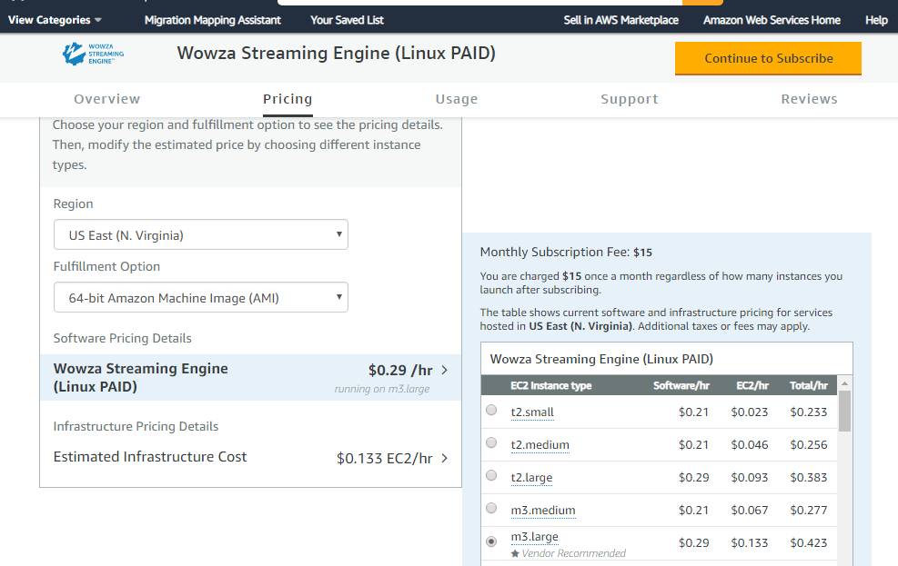

After the purchase the Wowza Streaming Engine (Linux PAID), you will get the confirmation email from wowza team your register email id, after that you can login in the wowza web portal.

<https://www.wowza.com/> “click on my My account, After the login you can change the First Name and Last name, For other change like company name you have to email them from your register email id or you can create a ticket regarding the other issue of wowza related. In login port of wowza

you can buy as per your requirement like sitelock for the SSL certificate from wowza”. 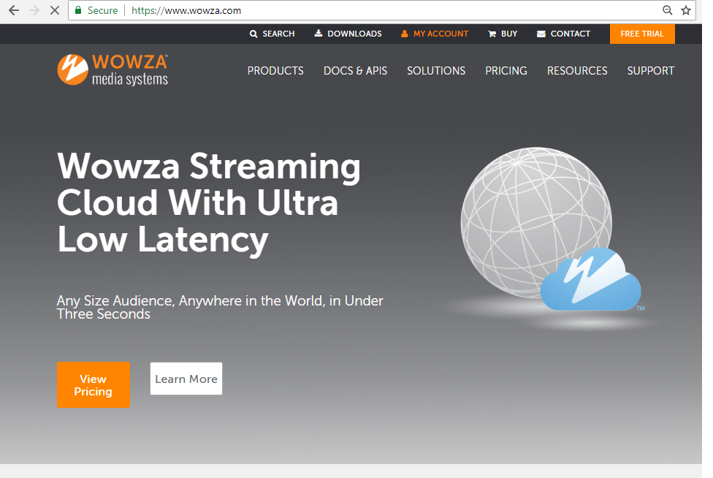

**AWS Login Details:-**

<https://console.aws.amazon.com>  
User and Password: - information already share

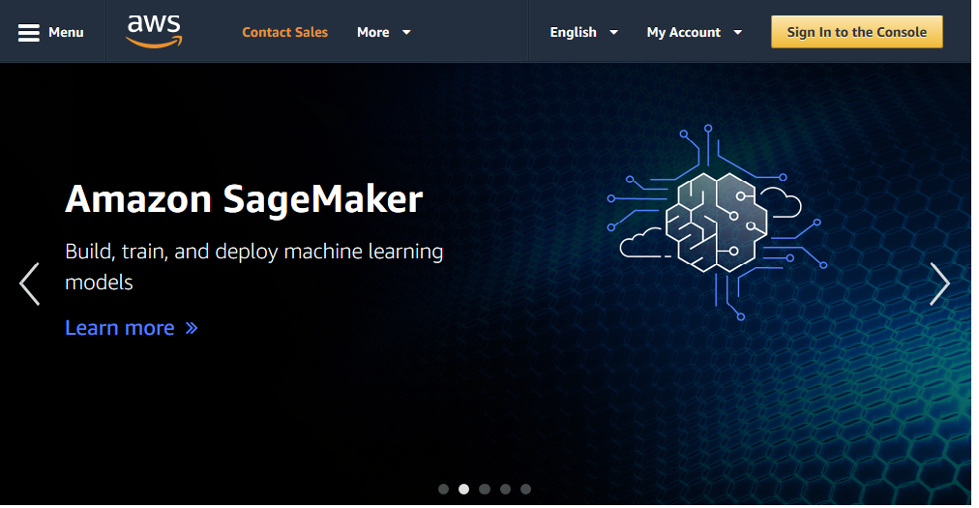

**Wowza Engine Manager Login**

[http://13.***.**.245:8088](http://13.***.**.245:8088) “User and Password: - information already share”

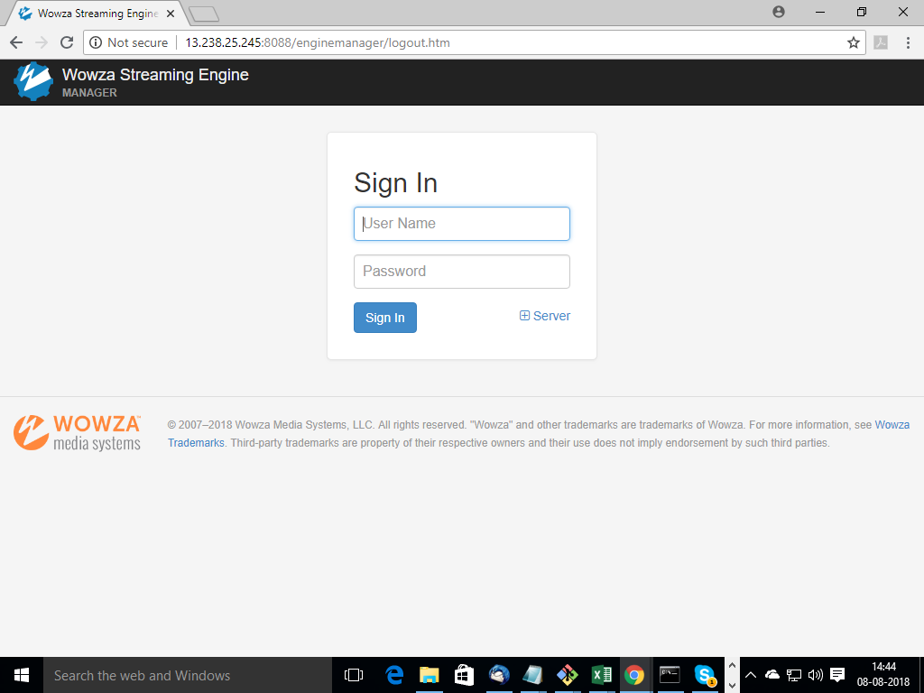

After the login Home page show the status and basic information show:-

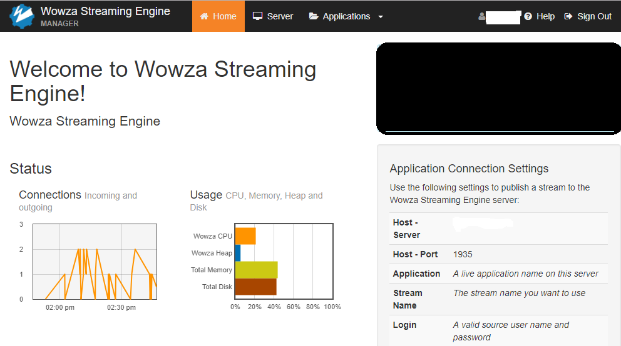

Server Tab show the information license and other information:-

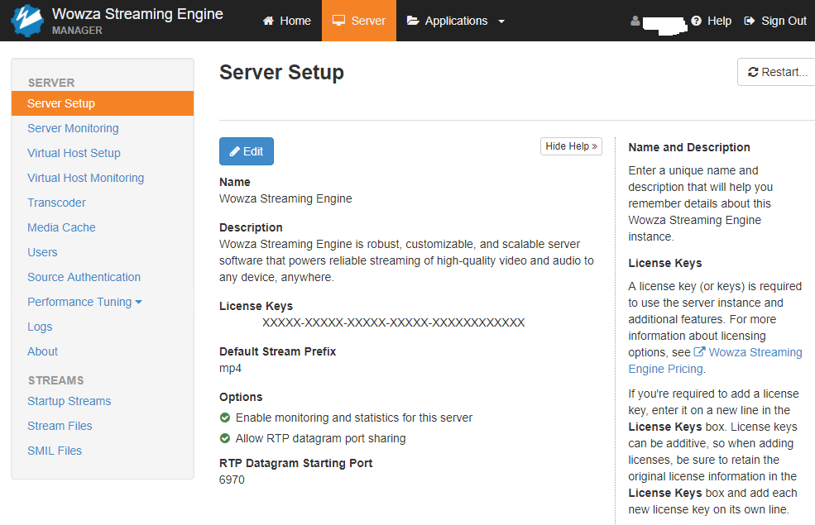

Application Tab:- used for enable disable and edit the options

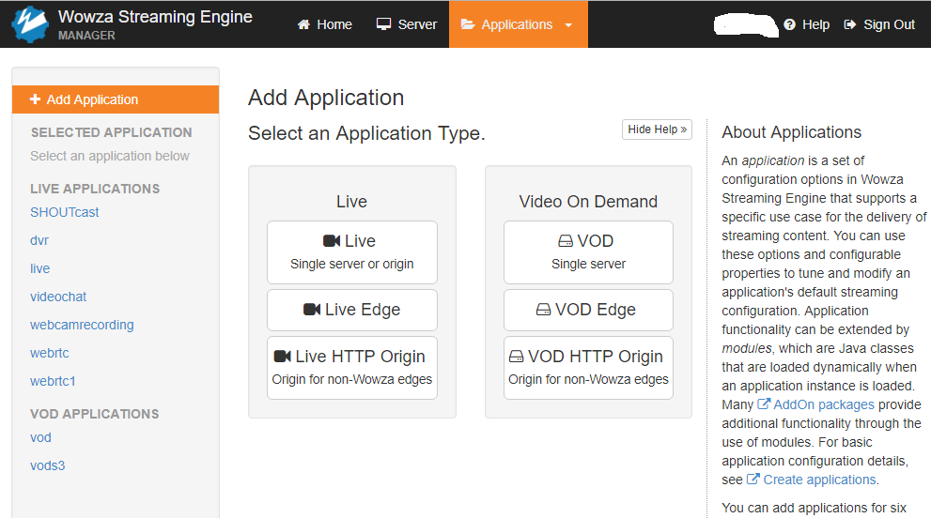

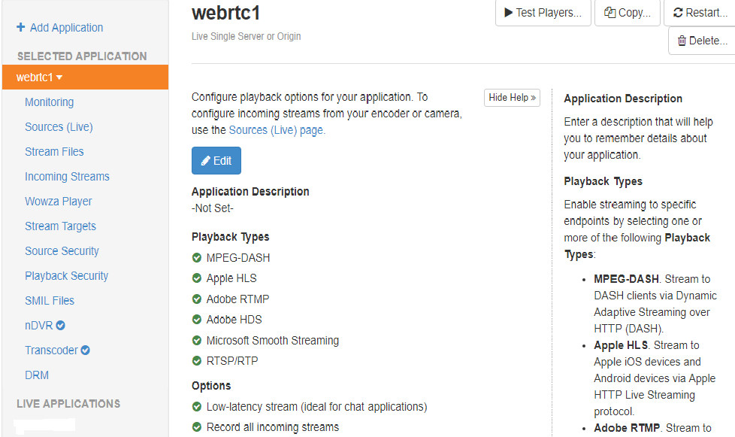

User and Password: - information already share

.**Pem file name** = Wowza-webrtc.pem

**Command to start or stop the Wowza steam engine**:-

sudo service WowzaStreamingEngine start

sudo service WowzaStreamingEngine stop

**wowza steam engine default location :-**

/usr/local/WowzaStreamingEngine-4.7.5/

**S3 Bucket storage**:-

The wowza steam video store in wowza steam engine and video thought in S@ bucket “Wowza-videos” after that s3 steam video link appear. Example: - https://s3-ap-southeast-2.amazonaws.com/wowza-vedio/streamname.mp4

